Answer Sheet – COSC2506 Practical Test 1 (30% - 25 Points)

Task 1 (Q1-Q4 – 3x1+1x2 = 5 points)
Copy your answers/outputs from the terminal here.

student@ubuntu:~ sudo passwd Vu
New password:
Retype new password:
Passwd: password updated successfully
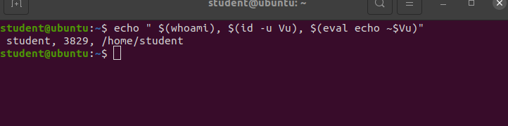

Task 2 (Q1 – 1 point)
Copy your answer/output from the terminal here.
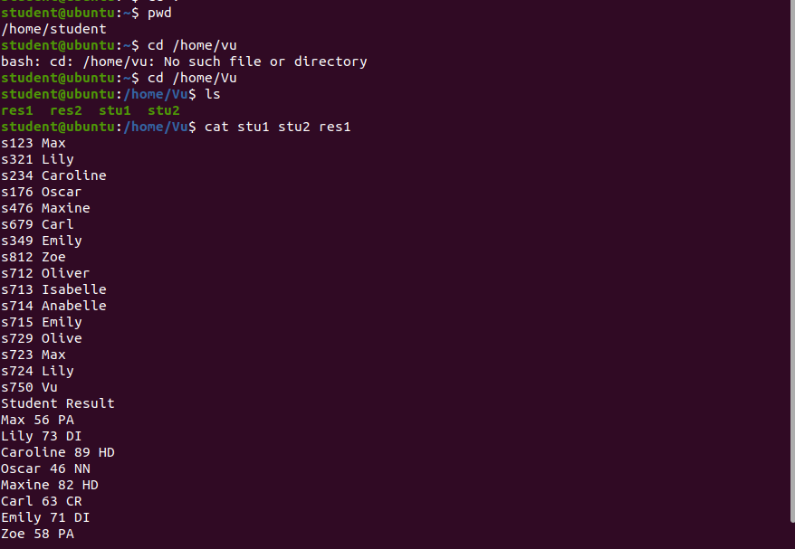

Task 3 (Q1-Q6 – 2x1+4x2= 10 points)
Copy your answers/outputs from the terminal here.
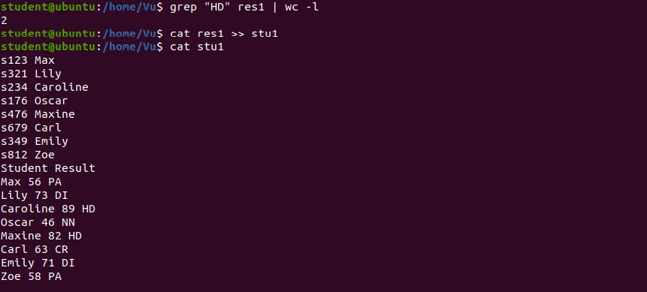

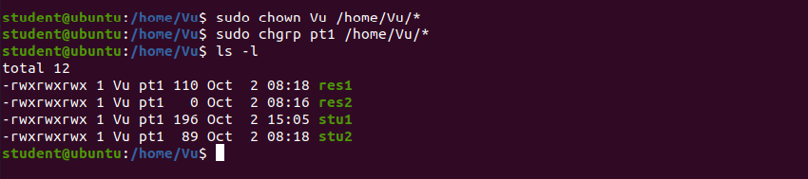

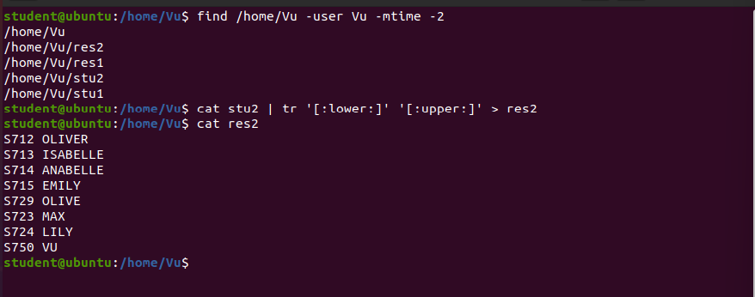

Task 4 (Q1-Q3 – 3x1 = 3 points)
Copy your answers/outputs from the terminal here.

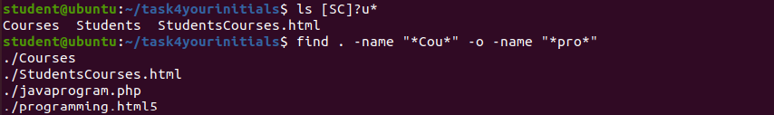

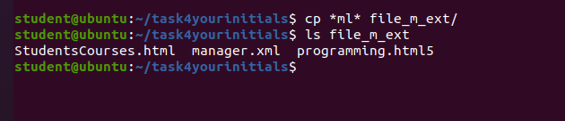

Task 5 (Scripts – 2x3 = 6 points)

----------------------------------------------------------------------------------------
Script1 (script1.bash) Code

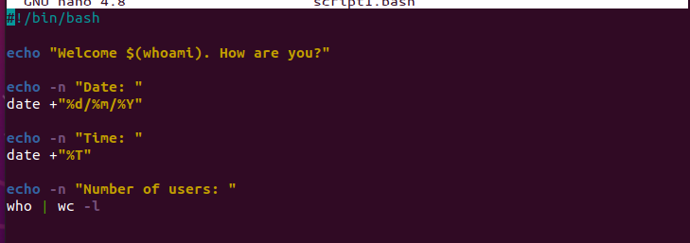
Script1 (script1.bash) Output
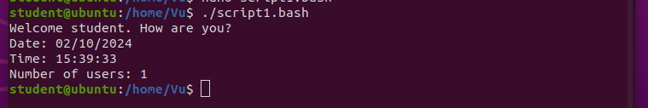

----------------------------------------------------------------------------------------
Script2 (script2.bash) Code

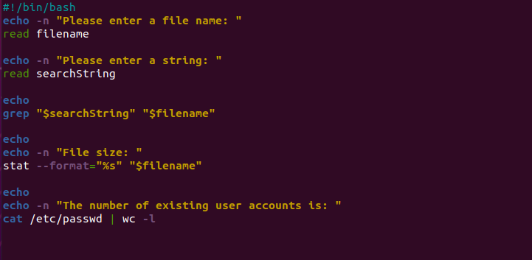

Script2 (script2.bash) Output

